Apply virtual services to route all requests to v1

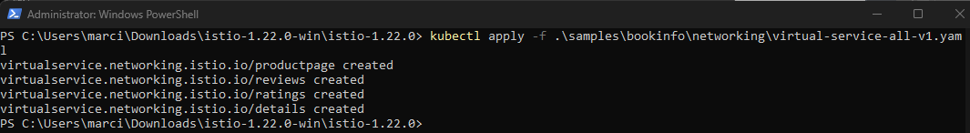

Display defined routes

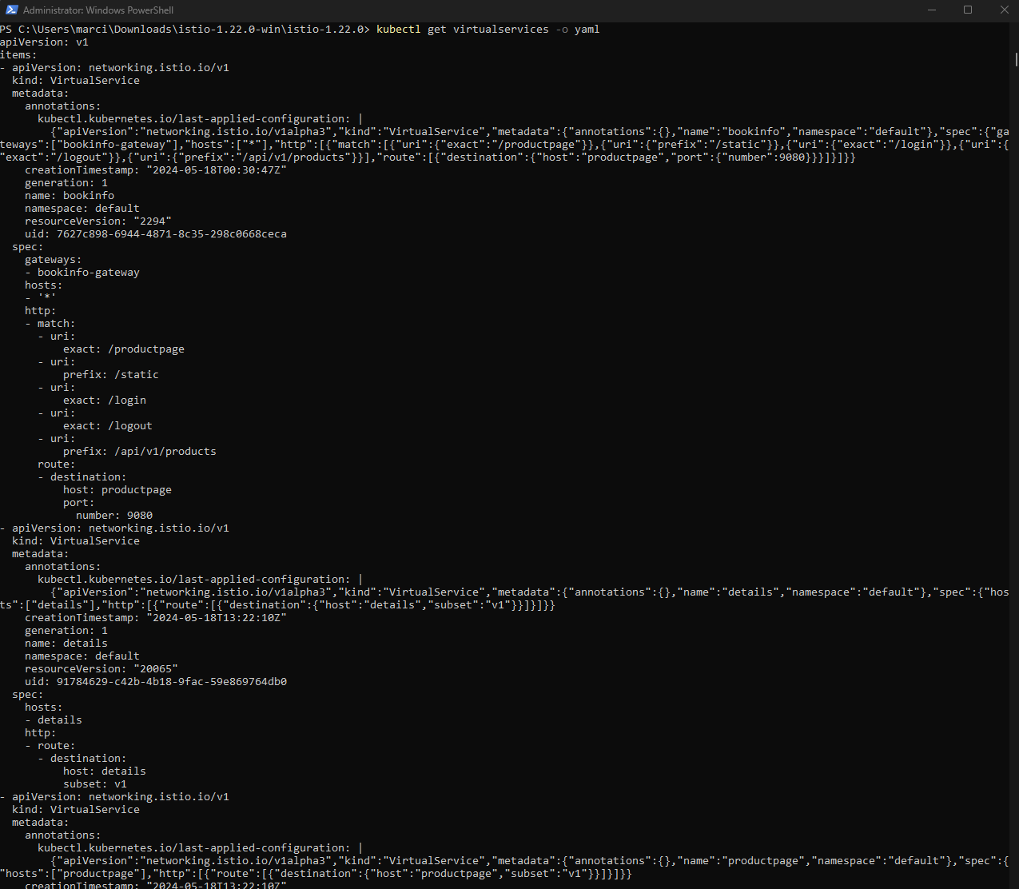

Display subset

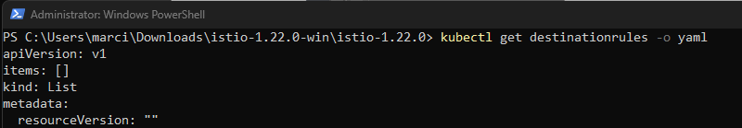

Ratings not displaying on v1

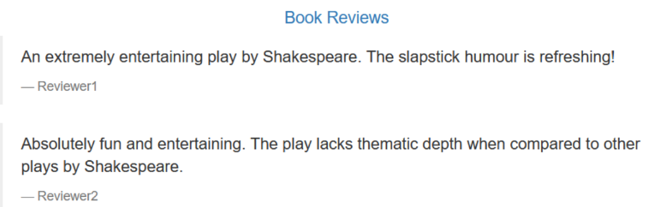

Route to v2 if end user name is ‘Jason’

Login as Jason and see rating stars

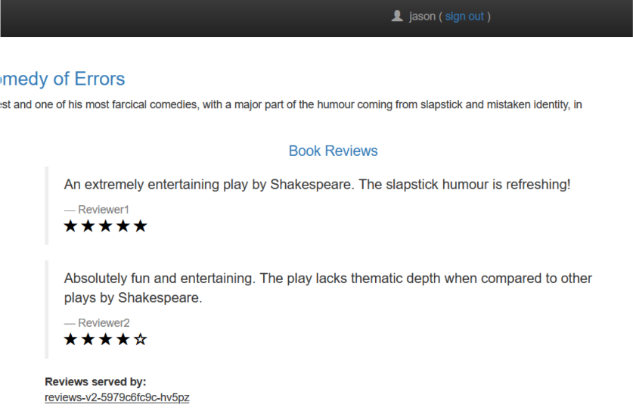

Sign in as not Jason and see no ratingsdue to different route



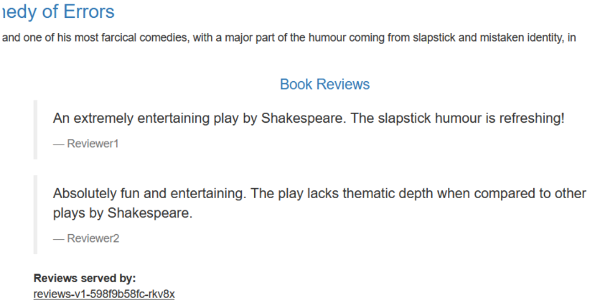

Remove routing rules

